SCHOOL OF COMPUTER SCIENCE AND ARTIFICIAL INTELLIGENCE |  |  |  |  | DEPARTMENT OF COMPUTER SCIENCE ENGINEERING
Program Name: B. Tech |  |  |  | Assignment Type: Lab |  |  | Academic Year:2025-2026
Course Coordinator Name |  |  |  | Venkataramana Veeramsetty
Instructor(s) Name |  |  |  | Dr. V. Venkataramana (Co-ordinator)  Dr. T. Sampath Kumar  Dr. Pramoda Patro  Dr. Brij Kishor Tiwari  Dr.J.Ravichander  Dr. Mohammand Ali Shaik  Dr. Anirodh Kumar  Mr. S.Naresh Kumar  Dr. RAJESH VELPULA  Mr. Kundhan Kumar  Ms. Ch.Rajitha  Mr. M Prakash  Mr. B.Raju  Intern 1 (Dharma teja)  Intern 2 (Sai Prasad)  Intern 3 (Sowmya)  NS_2 ( Mounika)
Course Code |  |  | 24CS002PC215 | Course Title |  | AI Assisted Coding
Year/Sem |  |  | II/I | Regulation |  | R24
Date and Day  of Assignment |  |  | Week6 - Monday | Time(s)
Duration |  |  | 2 Hours | Applicable to  Batches
Assignment Number:11.5(Present assignment number)/24(Total number of assignments)
 | Q.No. | Question |  |  |  |  |  | Expected Time  to complete
 | 1 | Lab 11 – Data Structures with AI: Implementing Fundamental Structures  Lab Objectives  - Use AI to assist in designing and implementing fundamental data structures in Python.  - Learn how to prompt AI for structure creation, optimization, and documentation.  - Improve understanding of Lists, Stacks, Queues, Linked Lists, Trees, Graphs, and Hash Tables.  - Enhance code quality with AI-generated comments and performance suggestions.  Task 1: Smart Contact Manager (Arrays & Linked Lists)  Scenario:  SR University’s student club wants a simple Contact Manager App to store members’ names and phone numbers. The app should allow adding, searching, and deleting contacts efficiently.  - Use arrays to store contacts initially.  - Implement the same system using a linked list for dynamic memory allocation.  - Compare both approaches (array vs. linked list) in terms of insertion and deletion efficiency.  - Use GitHub Copilot suggestions to implement search and delete methods  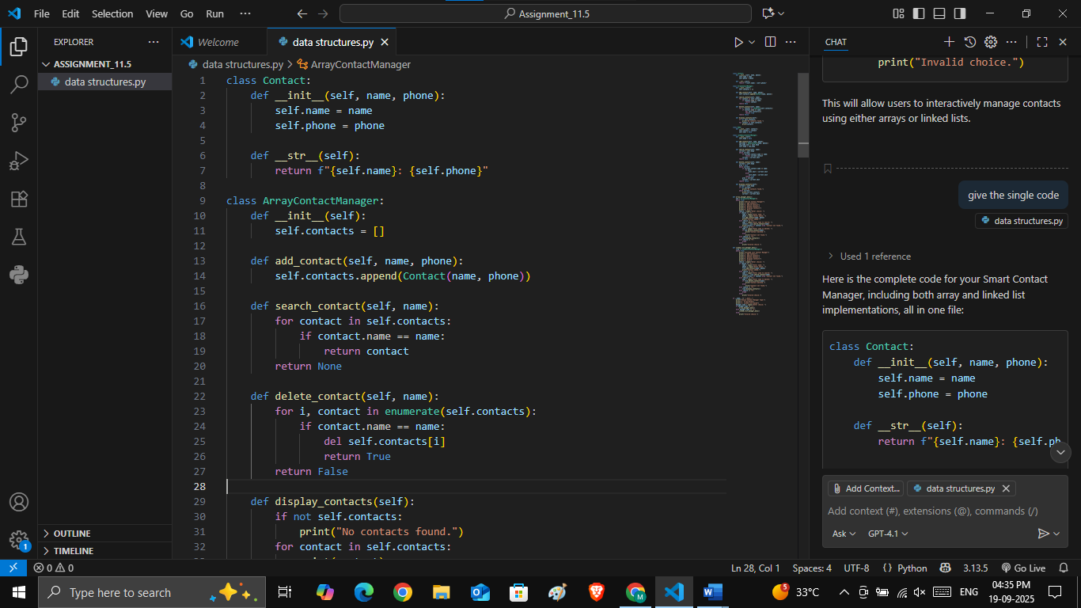  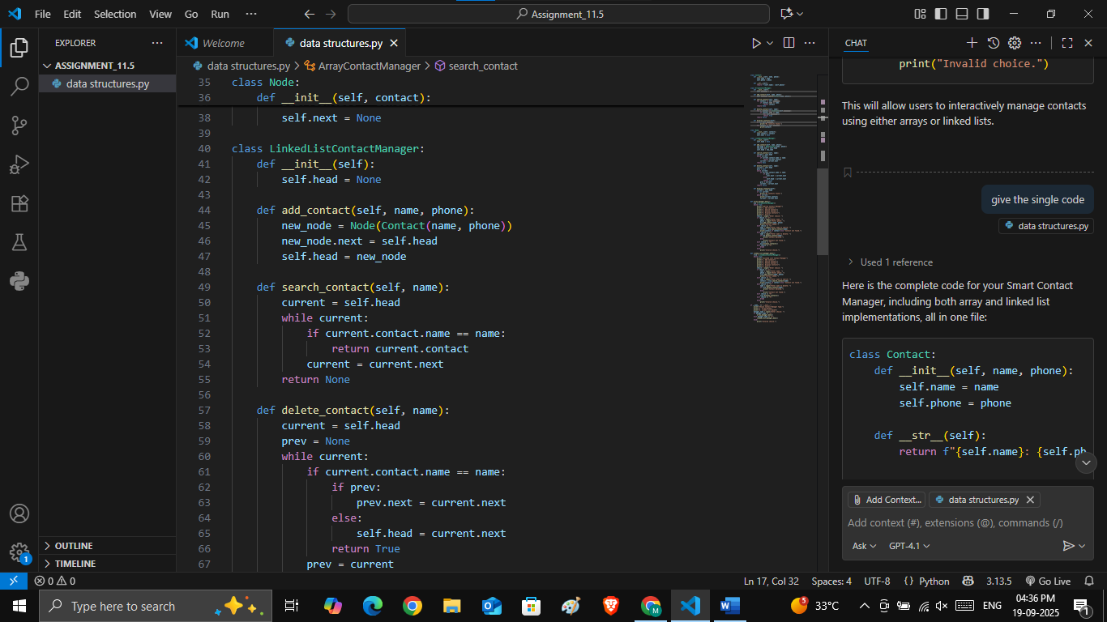  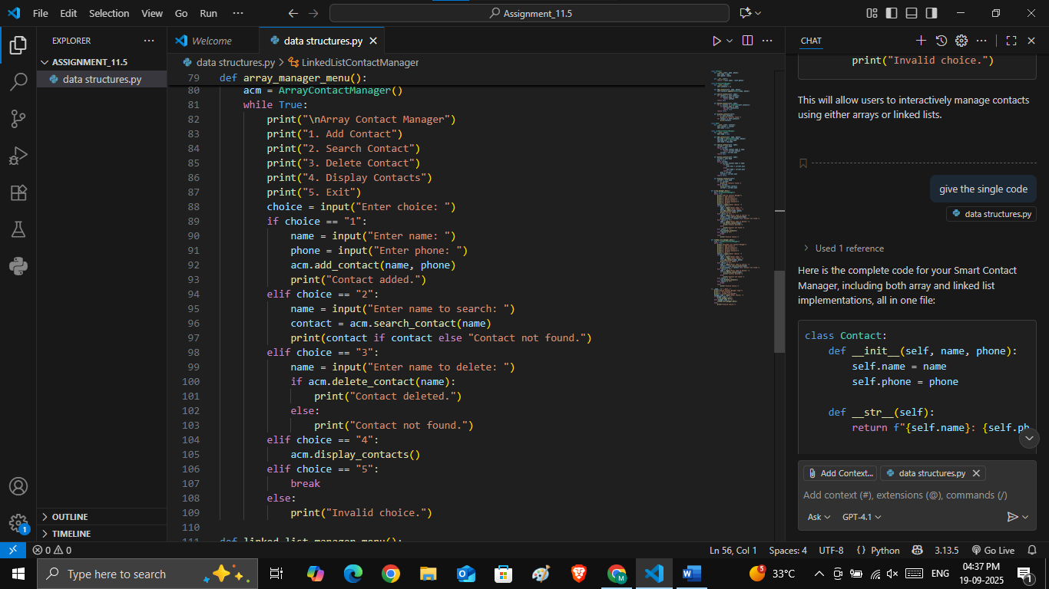  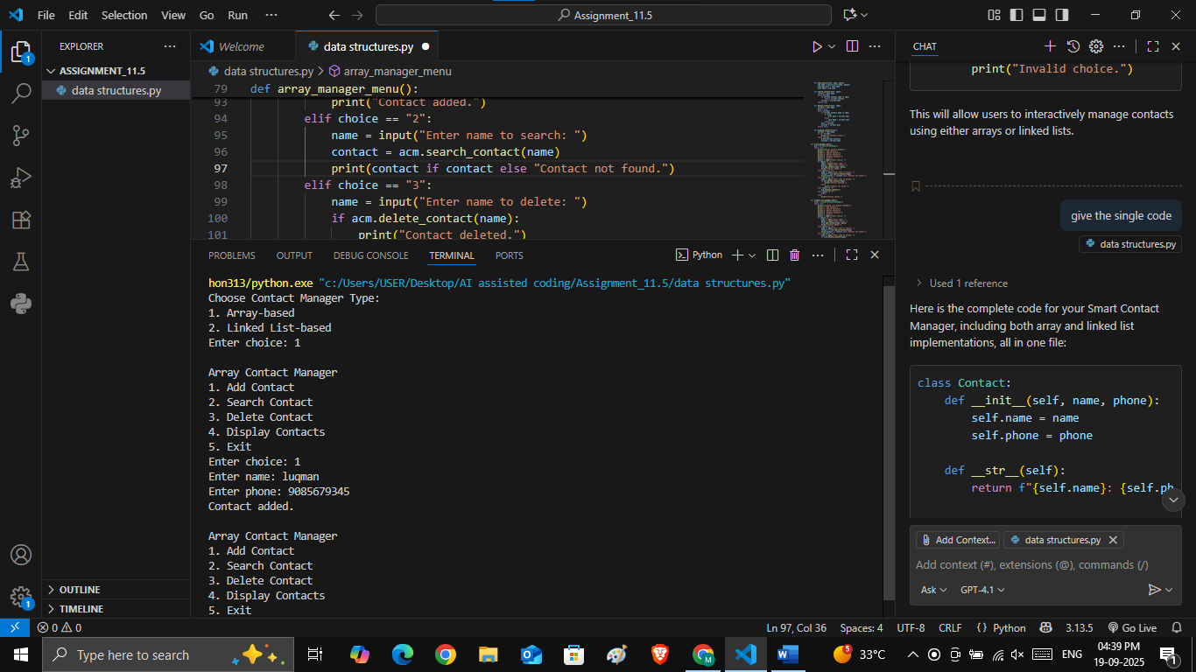  Task 2: Emergency Help Desk (Stack Implementation)  Scenario:  SR University’s IT Help Desk receives support tickets from students and staff. Since urgent issues need to be resolved in the order they were received, but escalation requires “last in, first out,” a stack-based system is ideal.  - Implement a stack to handle support tickets.  - Provide operations: push(ticket), pop(), and peek().  - Simulate at least 5 tickets arriving and being resolved.  - Use Copilot AI to suggest additional stack operations (like checking if stack is empty or full).  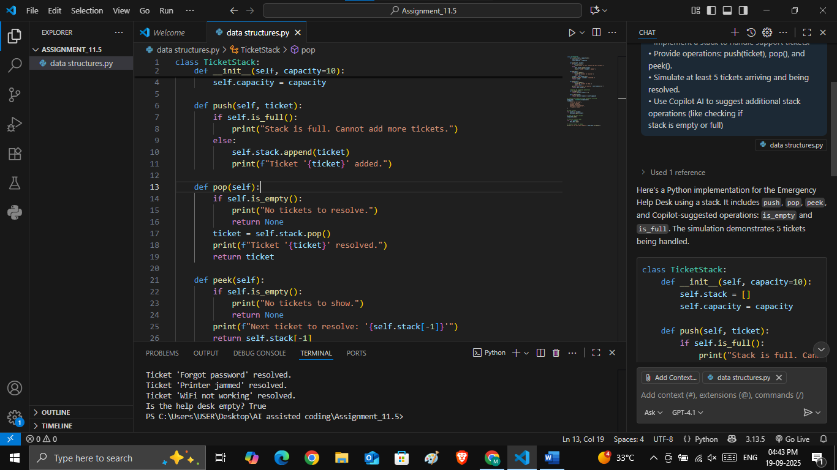  Task 3: Library Book Search (Queues & Priority Queues)  Scenario:  The SRU Library system manages book borrow requests. Students join a queue when they request books. However, faculty requests should be given higher priority.  - Implement a queue for book requests (FIFO).  - Extend it to a priority queue where faculty members’ requests are served before students.  - Use Copilot to generate enqueue and dequeue methods.  - Test with a mix of student and faculty requests.  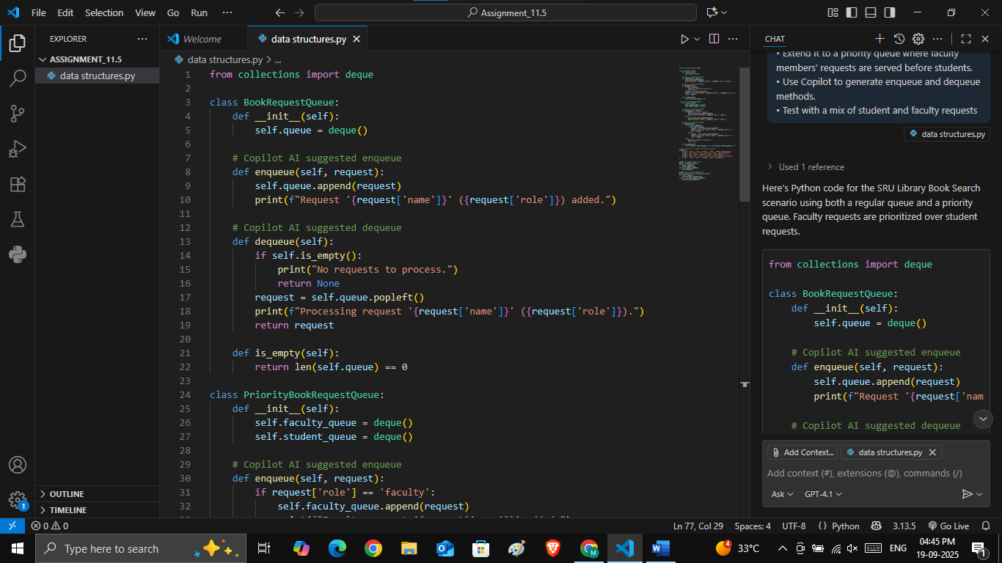  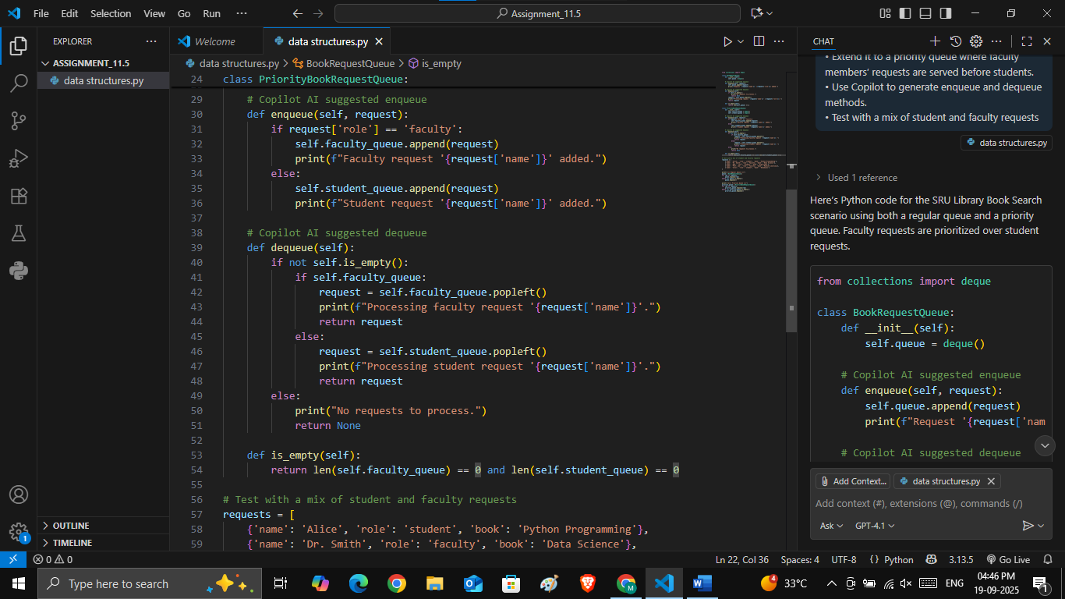  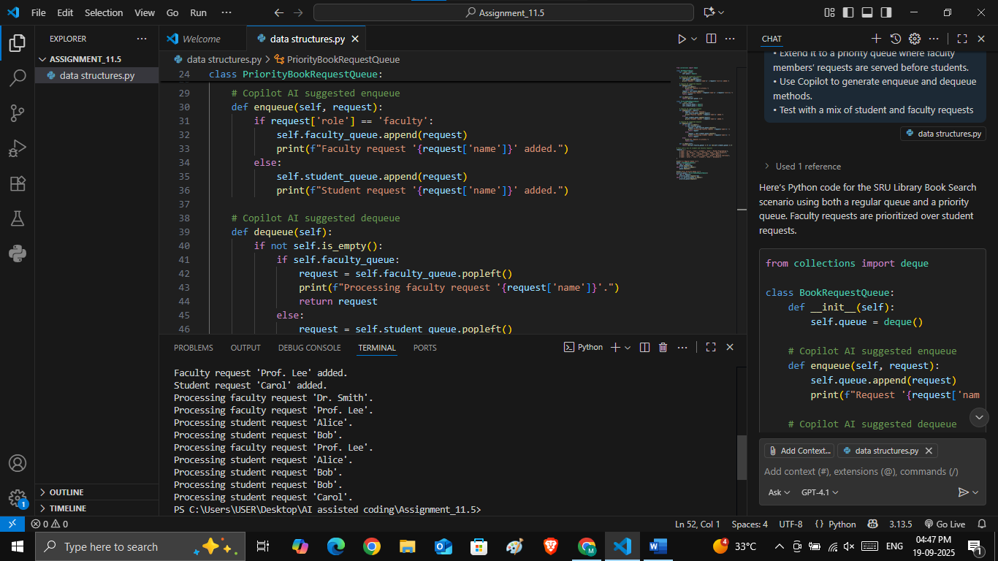  Task 4: Navigation Assistant (Trees & Graphs)  Scenario:  The university’s navigation app helps new students find classrooms. Buildings and rooms are represented as nodes connected by paths. A graph or tree structure can model this system.  - Create a binary search tree (BST) to store building names in alphabetical order.  - Implement insert, search, and traversal (inorder, preorder, postorder) using Copilot.  - Extend the system into a graph representation of rooms and paths.  - Implement a shortest path algorithm (like BFS) with Copilot’s assistance.  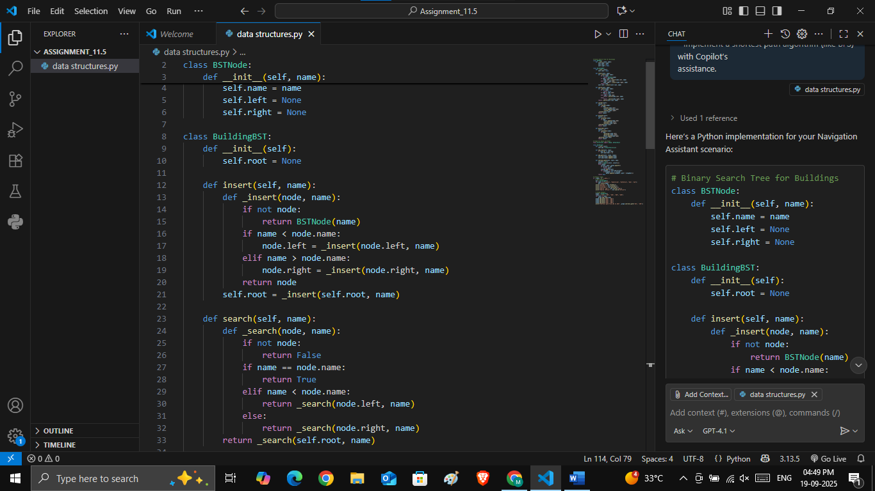  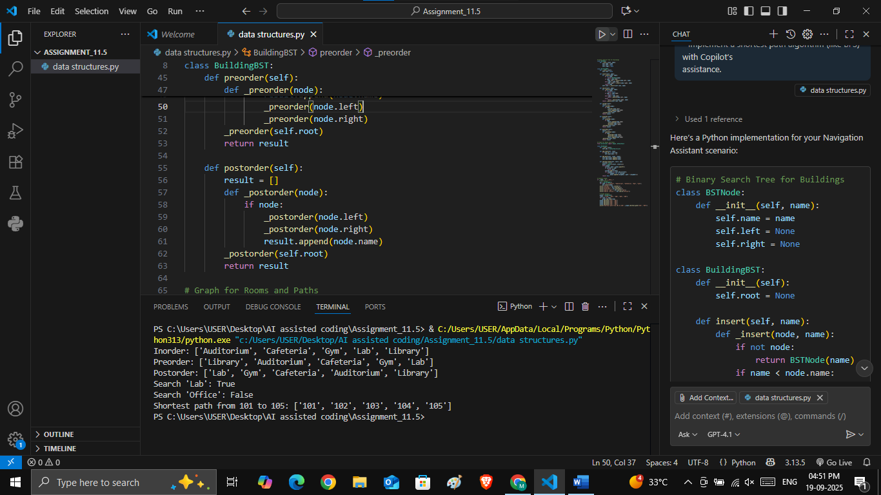 |  |  |  |  |  | Week 6 - Friday

